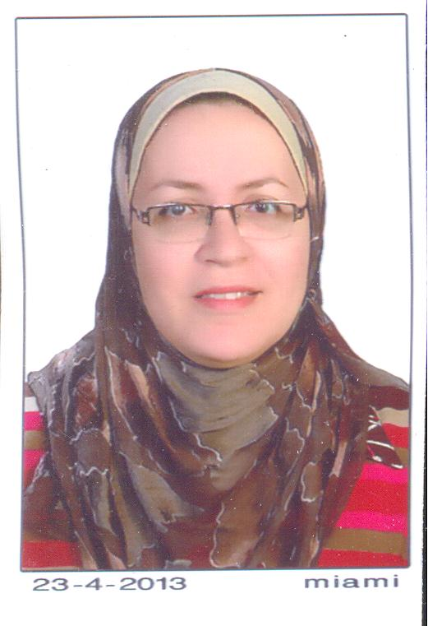
Dr. Doaa Ahmed Fouad Abdelgawad
MD, PhD Cardiology
Assiut University Hospital
Cardiology Department
Assiut – Egypt
Tel.:002-088-2296069,
002-01001085828
Fax: 002-088-2333327
Fax: 002-088-2356755
Email: fouaddoaa@yahoo.com

CURRICULUM VITAE

Name: Doaa Ahmed Fouad Abdelgawad
Date of Birth: 30 – 11 – 1968
Nationality: Egyptian
Marital status: Married
Current Job: Professor of cardiology and head of cardiology department, Faculty of medicine, Assiut University, Egypt.

- Qualifications:
*M.B.B.ch.: Assiut University, September –1992 with very good degree.
* M.Sc. of Cardiology: Assiut University, December – 1996, with very good degree. .
Title:" Doppler Echocardiography of clinically normal mitral valve"
*PhD of Cardiology: Assiut University, June-2002,
Title:"Short and long term effects of VVI and DDD pacing on cardiac dimensions and functions"
- Appointments:
-Resident of cardiology at Assiut University Hospital (March 1993 - July 1997).
-Assistant lecturer of cardiology at the Cardiology department, Faculty of Medicine, Assiut University Hospital (July 1997 –June 2002).
-Lecturer of cardiology at the Cardiology department, Faculty of Medicine, Assiut University Hospital starting from July 2002 to September 2007.
- Associate professor of cardiology at the Cardiology department, Faculty of Medicine, Assiut University Hospital starting from September 2007 to October 2012.
- Professor of cardiology at the Cardiology department, Faculty of Medicine, Assiut University Hospital starting from October 2012 till now.
- Head of cardiology department, Faculty of Medicine, Assiut University Hospital starting from October 2013 till now.

- Experiences:
1- Working for 20 years in the cardiology department, Assiut University Hospital as a resident, assistant lecturer, lecturer, associate professor, and professor of cardiology.
-Echocardiography: working in the echocardiography laboratory with good experience in adult echocardiography, tissue Doppler imaging, speckle tracking, and RT3D echocardiography.
- Device implantation: I -myself- have implanted more than 500 pacemakers of various types (single chamber pacemakers, dual chamber pacemakers, cardiac resynchronization therapy, and intracardiac defibrillator devices) in the cardiology department.
- Coronary angiography and angioplasty: I -myself- have performed more than 1500 cases of diagnostic coronary angiography and coronary angioplasty.

2- Post-doctor scholarship (from 1-6-2009 to 25-11-2009): Training on CRT and ICD implantation with implantation of 50 devices in Leiden University Medical Centre, the Netherlands.

- Scientific Researches:
- International Publications:
1-Bifocal Right Ventricular Pacing in Congestive Heart Failure: A Pilot study. Doaa A. Fouad, Dalia M. Ragab, Hassan K. Nagi, Nadia M. Selim. Presented in the XIII World Congress on Cardiac Pacing and Electrophysiology, Rome , Italy , Giornale Italiano di Aritmologia e Cardiostimolazione, Vol 10 (No. 3), Supplement 2, December 2007. Assiut Medical Journal, March, 2007.

2-Usefulness of real-time three dimensional echocardiography in assessment of response to cardiac resynchronization therapy: compared to two dimensional tissue Doppler imaging. Doaa A. Fouad, M.D. Cardiology Departmen Faculty of medicine, Assiut University. Presented in the ECAS, Paris-France 2007. The Egyptian Heart Journal. 62(2), December 2010:224-236.

3-Evaluation of recently validated non-invasive formula using basic lung functions as new screening tool for pulmonary hypertension in idiopathic pulmonary fibrosis patients. Maha K. Ghanem, Hoda A. Makhlouf, Gamal R. Agmy, Hisham M. K. Imam¹, Doaa A. Fouad². Departments of Chest Disease, Diagnostic Radiology¹ and Cardiology², Faculty of Medicine, Assiut University Hospital, Assiut – Egypt. Annals of Thoracic Medicine, 4 (4) October - December 2009, 187-196.

4-Trans-venous lead removal without the use of extraction sheaths, results of more than 250 removal procedures. Mihály K. de Bie, MD, Doaa A. Fouad*, MD, PhD, C. Jan Willem Borleffs, MD, Johannes B. van Rees, MD, Joep Thijssen, MD, Serge A. Trines, MD, PhD, Marianne Bootsma, MD, PhD, Martin J. Schalij, MD, PhD, Lieselot van Erven, MD, PhD. From the Department of Cardiology, Leiden University Medical Center, the Netherlands, and *Aissut University Hospital, Egypt. Europace (2012) 14, 112–116.

5- The role of RT3DE to improve response to cardiac resynchronization therapy after optimal positioning of the resynchronization lead: A prospective study. Doaa Ahmed Fouad, MD,PHD, Randa M Shamseldeen, Cardiology and Public Health Departments, Assiut University Hospital. Presentd at Euroecho, Budabest December 2011.
6- Impact of residual coronary artery disease on patients undergoing TAVI: A meta-analysis of adjusted observational studies. Salma Taha MD, Claudio Moretti MD, PhD, Fabrizio D’Ascenzo MD, Nicolas M Van Mieghem MD, Pierluigi Omedè MD, Antonio Montefusco MD, Mohamed Abdel Ghany MD, Doaa Fouaad Prof , Salwa Demitry Prof, Giuseppe Biondi Zoccai MD, and Fiorenzo Gaita. 1Cardiology Department, Assuit University, Egypt.
International Journal of Cardiology,February 2015, Volume 181, Pages 77–80 DOI: http://dx.doi.org/10.1016/j.ijcard.2014.11.150

7- The Number of GT(n) Repeats in the Hemeoxygenase-1 Gene Promoter is Increased in Pediatric Heart Failure but is Unrelated to Renal, Antioxidant and Anti-inflammatory Markers
Sherif Sayed1, Naglaa K. Idriss2, Andrew Blann3, Hayam G. Sayyed4, D. M. Raafat5, Doaa Fouad6, M. S. K. Tawfeek5.
Departments of Anasthesia¹, Biochemistry², 4 Medical Physiology,pediatrics5 and Cardiology6, Faculty of Medicine, Assiut University, Assiut – Egypt &3University of Birmingham Center for Cardiovascular Science, Birmingham, UK
Pediatric Cardiology Journal, March 2015, DOI 10.1007/s00246-015-1146-0.

II- Publications in Egypt:
1- The association of PvuII lipoprotein lipase gene Polymorphism with coronary artery disease in Egyptian territory. Hanan M Ahmed¹, Doaa A Fouad², Omar Herdan¹, Hala K Elshereef¹, Lubena M Tag ³, Ebtsam Farouk³, Madleen³, Hebat alla G Rashed³, waffaa Tohamy El-Sherif³. Departments of ¹Internal Medicine, ²Cardiology. Assiut University Hospital. The Egyptian Heart Journal. 62 (2), June 2010:339-349.
2- Usefulness of Doppler Tissue Imaging for Assessment of Left Ventricular Functions at Long Term VDD and DDD Pacing.
Doaa Ahmed Fouad, MD Cardiology, Assiut University Hospital.
The Egyptian Heart Journal. 58 (4), December 2006:220-235.
3- Pacing for Symptomatic AV Block: Safety and Efficacy of VDD compared to DDD pacing. Doaa Ahmed Fouad, MD, Hosam Hasan Aly, MD. Cardiology Department, Assiut University Hospital. Assiut Medical Journal.30 (3) September 2006:111-120.
4- CARDIAC TROPONINS IN CHILDREN WITH CHRONIC RENAL FAILURE. Mohamed M. Sayed¹, Mostafa Shafeek Khalaf¹, Doaa Ahmed Fouad², Maha A. Ibrahim³. From pediatric¹ ,Cardiology ²and clinical pathology ³departments, Faculty of Medicine,Assiut University. The Medical Journal of Cairo University. 74 (4), S III, December, 2006:169-179.
5- Corrected QT dispersion improves the diagnostic performance of treadmill exercise test in diagnosing coronary artery disease.
Hosam Hasan Aly, MD. Doaa Ahmed Fouad, MD, Mohamed Hosam Maghraby MD*.Cardiology and Medicine* Departments, Assiut University Hospital. Assiut Medical Journal. 30 (3) September 2006:99-110.
6- A comparative study between enoxaparin & unfractionated heparin in patients with ST segment elevation myocardial infarction. In-hospital outcome study. Doaa A. Fouad MD, Nadia M Selim MD, Heba Elnaggar MBBch, M Eltahtawy* MD.The departments of cardiology and clinical pathology*, Assiut University. Presented in the 27th summer meeting of the Egyptian Society of Cardiology; June 2005.
7- The prognostic value of endothelin– 1 in acute coronary syndromes. Doaa A. Fouad MD, Samir Abdelkader MD, Lubna Tageldin MD*, Ayman M Asham MBBch. The departments of cardiology and clinical pathology*, Assiut University. Assiut Medical Journal. 23 rd annual conference, March 2005:37-46.
8- Plasma fibrinogen as an independent risk factor for acute coronary syndromes. Doaa A Fouad MD, Samir Abdelkader MD, Mahmoud Y Eltahtawy* MD, Ramez A Reiad MBBch. The departments of cardiology and clinical pathology*, Assiut University. The Egyptian Heart Journal. 56 (2), June 2004:377-391.
9- Evaluation of a rapid diagnostic protocol for diagnosis of chest pain assessment in emergency department. Doaa A. Fouad, M.D., Fatma G Elnaggar Mb.ch.ch,, Monazzam A. Aal, M.D.*, Yehia T. Kishk, M.D. Cardiology Department, Clinical Pathology Department *, Faculty of medicine, Assiut University. The Egyptian Heart Journal. 58 (3), September 2006:639-645.
10- Assessment of regional wall motion abnormality using parametric imaging of real time three dimensional echocardiography compared to two-dimensional echocardiography : validated by coronary angiography. Ayman M. Asham , Doaa A. Fouad, Nadia M. Selim, Cardiology Department, Assiut University Hospital. Cairo Medicine Journal, June 2012.

- The Role of Real Time Three Dimensional Echocardiography to Improve Response to Cardiac Resynchronization Therapy after Optimal Positioning of the Resynchronization Lead: A Prospective Study. Doaa A. Fouad, Randa M. Shamseldeen. Egyptian Heart Journal, June 2012.
- Achieving More Optimum Cardiac Synchronization Using Dual-site Left Ventricular Stimulation: A Pilot Study. Doaa A Fouad, MD, Khaled M Elmaghraby, MD. Heart Mirror Journal, June 2012.
- Assessment of myocardial strain by 2D Speckle tracking imaging in normal subjects and advanced heart failure patients. Doaa A Fouad, MD, Yousra M Ghazally, MBBCH, Salwa Roshdy Dimetry, MD. Heart Mirror Journal, January 2013.
- Hospital-based prevalence of different etiologies of dilated cardiomyopathy and concomitant arrhythmias in an Egyptian Tertiary Hospital: Correlation to mortality. Doaa A Fouad, MD, Eman M Hamam, MBBCH, Salwa Roshdy Dimetry, MD. Assiut Medical Journal, May 2012.
- Plasma level of soluble receptor for advanced glycation end product levels, hypoxia induced factor 1, and angiogenin in ischemic heart diseases: Relationship to the severity of diseases. Doaa A Fouad & Naglaa K Idriss. Assiut Medical Journal 35 (2) May 2011:143-153.

